

**YPSI/Z4 BASSINET**

**Instructions for Removing Headrest Strap**

1. Un-zip the rear section of the Bassinet white liner.
2. Lift the rear section of the white liner upwards to locate the headrest strap. You will also find the date code below the white liner.

3. From the inside of the Bassinet, pull the headrest strap all the way through the hole.

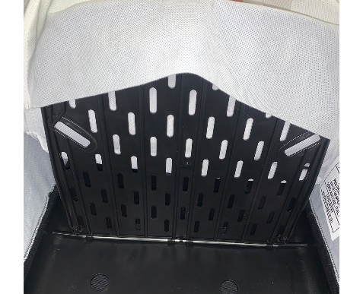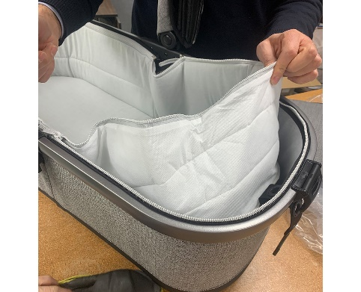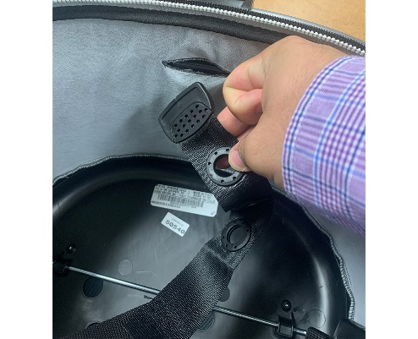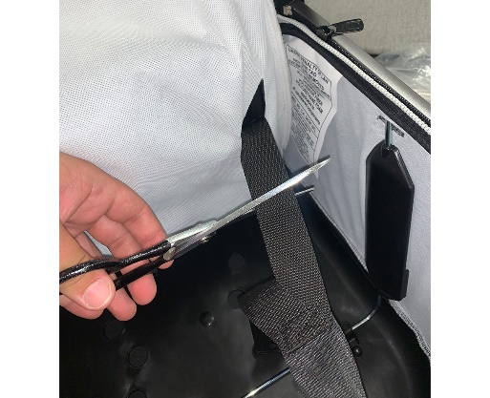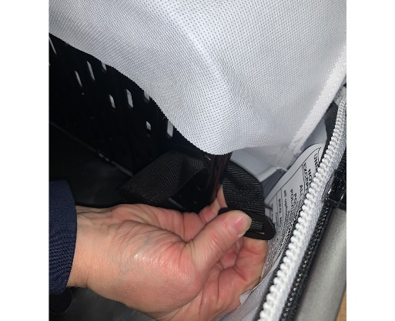

4. Cut both straps that attach to the backrest.

5. Once cut, grab the strap from the front of the black headrest and pull through until fully removed.

6. Slide the white liner sleeve back over the black backrest and lay it down horizontally.

7. Re-zip the rear section of the Bassinet white liner to the shell of the Bassinet.